Project Title:
Applicant: |  | Company:
Title: |  | Address:
Phone: |  | City:
E-mail: |  | Province:
Is this an ACWA Project? Yes No
If yes, identify ACWA project type:
Does this research align with any City of Calgary’s Wastewater Research Interests? If yes, under which topic and how?

Facilities Access and Use
ACWA Lab: |  | Prep Area | Analytical | Microscopy | Microbiology
Details:
Streams: |  | Pools | Riffles | Head pond | Intake
Details: | Describe pools or riffles of interest for research using attached map and provide description below.
Frequency of sampling
# of samples
Required Equipment:
Request for ACWA sampling support
Research Plant: |  | UF | RO | H₂O₂ | O₃
Details:
Office Space: |  | Yes | No
Details: |  |  | :

Time-line
Project Start Date:
Project End Date:
Sampling Duration:
Sampling Frequency: | Continuously (24-7) Work week (M-F)

Facilities Requirements
Unit Dimensions (l, w, h)
Power:
Source Water:
Potable Water:
Sanitary Line:
Telecommunications:
Other Requirements:
Project Description:
Do You Have Any Conflict(s) of Interest? (provide details)
Funding
Funding Source:
Total Project Funds:
Matching Funds:
ACWA user fee budget:

Health and Safety
Chemicals Needed:
Gases Generated:
Operating Pressures:
Risk Assessment:
Hazardous Waste:
Animal Care
Vertebrate Model: | Yes No
Protocol Number:
Additional Permits:

Analysis Requirements
Analysis | Detection Level |  | Proposed Method |  | Frequency

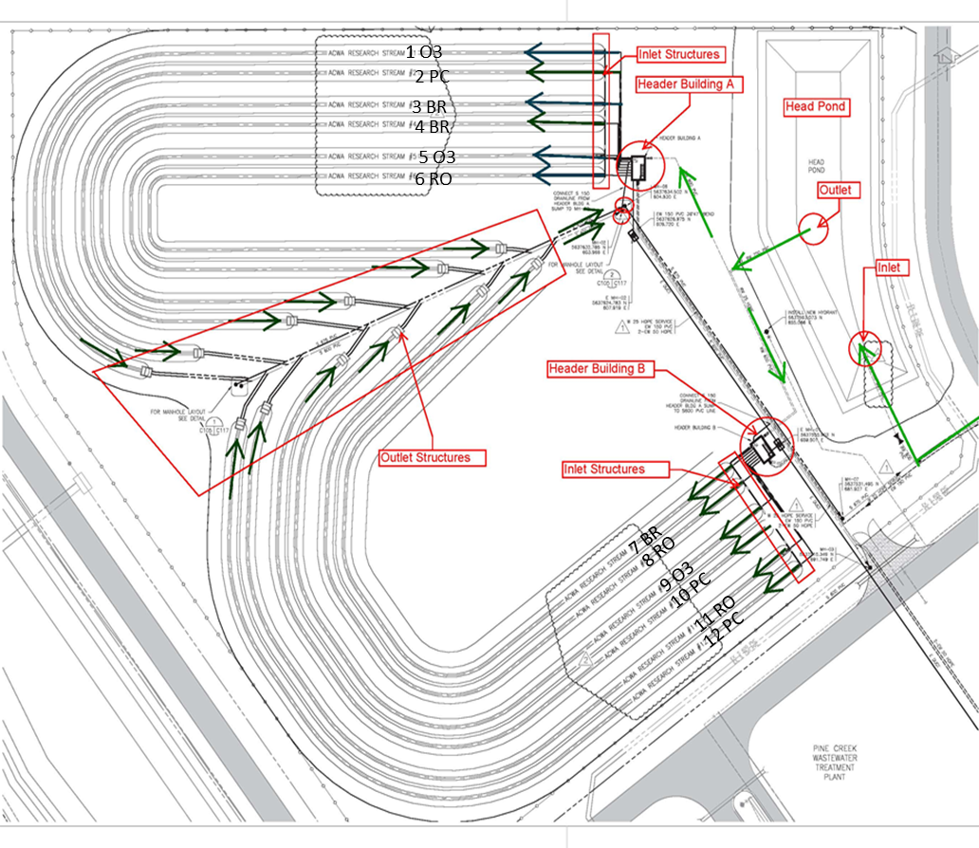
ACWA operates under the University – City Urban Alliance, which respects the rights and freedoms of both parties to conduct business in accordance with their principles and responsibilities. To access facilities, samples or data related to City of Calgary assets (e.g., Pine Creek, and therefore ACWA), researchers are expected to abide by the City of Calgary’s data sharing agreement, which includes review and approval from The City prior to conference or publication. Researchers have the academic freedom to make statements about their findings as they see fit, which may or may not include findings about City wastewater or wastewater treatment. When speaking about wastewater samples from the City of Calgary, it is preferred that they refer to them generically as “municipal wastewater ”. Research is to be conducted in accordance with the University of Calgary Research Integrity Policy (or equivalent from other institutions).https://www.ucalgary.ca/policies/files/policies/research-integrity.pdf

If this project is accepted, you agree to report to ACWA and to The City of Calgary, any publications, guest lectures/seminars and conference presentations (and identify relevant HQP) stemming from this project and use of ACWA facilities for the periods 1 January – 30 June and 1 July – 31 December of each year (digital signature or initials) .

