UofC Sponsored Clinical Trials
Health Canada CTA & CTA-A Preparation Checklist

All UofC sponsored investigator-initiated, clinical trials that require Health Canada approval must be submitted to Quality Assurance and Regulatory Compliance Office for review. The office will review all of the study related documentation from a regulatory perspective before approving the HC 3011 form for signature by the Associate Vice - President (Health Research).

The following checklist will assist you in ensuring that your study documents are ready for review by the QA and Regulatory Compliance Office.

Protocol Elements | Notes
□ All protocol elements as listed in GCP section 6 are included in the protocol
(refer to the Spirit Checklist for help)
□ A protocol signature page has been added to the protocol
□ A statement has been included indicating that the study will be conducted in accordance with GCP & Division 5 regulations
□ Monitoring methods have been addressed in the protocol
□ Definitions of SAE and ADR are included as well as reporting requirements & timelines
□ Eligibility criteria are consistent with the Investigator Brochure or Product Monograph
□ Information about the DSMB has been included in the protocol
Informed Consent | Notes
□ All elements for informed consent as outlined in GCP section 4.8.10 are included
□ ICF version date is included in the header or footer
□ Risks noted in the ICF are consistent with the risks outlined in the product monograph
Clinical Trial Application Documentation | Notes
Note: Please refer to the CTA guidance document for detailed instructions on CTA/CTA-A submission requirements. http://www.hc-sc.gc.ca/CTA Guidance
□ Cover letter must include the following:
- Type of submission (CTA or CTA-A)
- Reference to correspondence with HC prior to filing if applicable (e.g. Pre-CTA meeting information etc.)
- Name of sponsor (UofC), manufacturer, DIN owner or agent
- Brand name
- Reason for application (e.g. new indication/route/importing drug)
- Control number if known
- List of documents being submitted (include version dates)
- Information re: drug supply
- Cover letter must be signed by the QI
- Information from form 3011 (see table at end of checklist)
Note: a signed copy of the cover letter must be included in electronic format. A hard copy must also be submitted with the CD when the CTA/CTA-A is sent to Health Canada.
□ Most recent Product Monograph (PM)/Investigator Brochure (IB)
□ Placebo information is included if applicable
□ Protocol Safety and Efficacy Assessment Template (PSEAT) is consistent with the protocol
Health Canada 3011 Form | Notes
□ Current version of the HC 3011 form. Only the most current form will be accepted for submission.
□ Proper schedule is assigned as per Health Canada Drug Database
□ University of Calgary is listed as sponsor

□ Sponsor Contact:
Dr. Marcello Tonelli, Associate VP - Research(Health)
Administration Building 200
University of Calgary
2500 University Drive NW
Calgary, AB, Canada T2N 1N4
cello@ucalgary.ca
(403) 220-7833

□ contact for this drug submission is Qualified Investigator (QI)
Or if using one, the Contract Research Organization (CRO)
□ contact for the regulatory contact is Qualified Investigator (QI)
Or if using one, the Contract Research Organization (CRO)
□ list of active ingredients & strength is accurate as per protocol and PM
□ All non-medicinal ingredients have been entered accurately – note if the investigational product is marketed in Canada, it is not necessary to list the non-medicinal ingredients.
□ All brands, doses, strengths of study medications are listed
□ Information re: nanomaterials and animal sources has been accurately documented
□ Proposed indication is accurate – Note: the proposed indication is the indication for which you will be using the drug in your trial – this is not the indication for which the drug has been approved.
□ Route of administration is correct (e.g. oral, IV, IM, etc.)
□ Authorized signing official should be the Qualified Investigator.

Appendix 1 | Notes
□ Study drug is not being imported – appendix 1 is not applicable
□ Study drug is being imported. Authorization is correctly completed and
appendix 1 accurately lists the importing companies.
Appendix 2 – Not Applicable when UofC is listed as Sponsor
Appendix 3 | Notes
□ Protocol number and protocol title are correctly listed (Box # 82 & #83)
□ Market from which drug is being obtained is correctly identified (Box #84)
□ Clinical trial population identified matches that which is outlined in the
protocol
□ Clinical trial phase is accurately recorded and matches that which is identified in the protocol
□ REB refusals indicated as “no” or “not known” (Box # 87)
□ CTSI form enclosed is marked “no”
Note: The CTSI form should only be submitted to HC once REB & HC approvals have been obtained AND the study is ready to begin recruitment (i.e. all training completed etc.)
□ Investigator’s Department Head is listed as Senior Medical officer/Scientific Officer (Box # 89)
□ Dr. Marcello Tonelli is listed as Senior Executive Officer & all contact information is correct –

Dr. Marcello Tonelli, Associate VP - Research(Health)
Administration Building 200
University of Calgary
2500 University Drive NW
Calgary, AB, Canada T2N 1N4
cello@ucalgary.ca
(403) 220-7833

Cover letter should include a table similar to this:

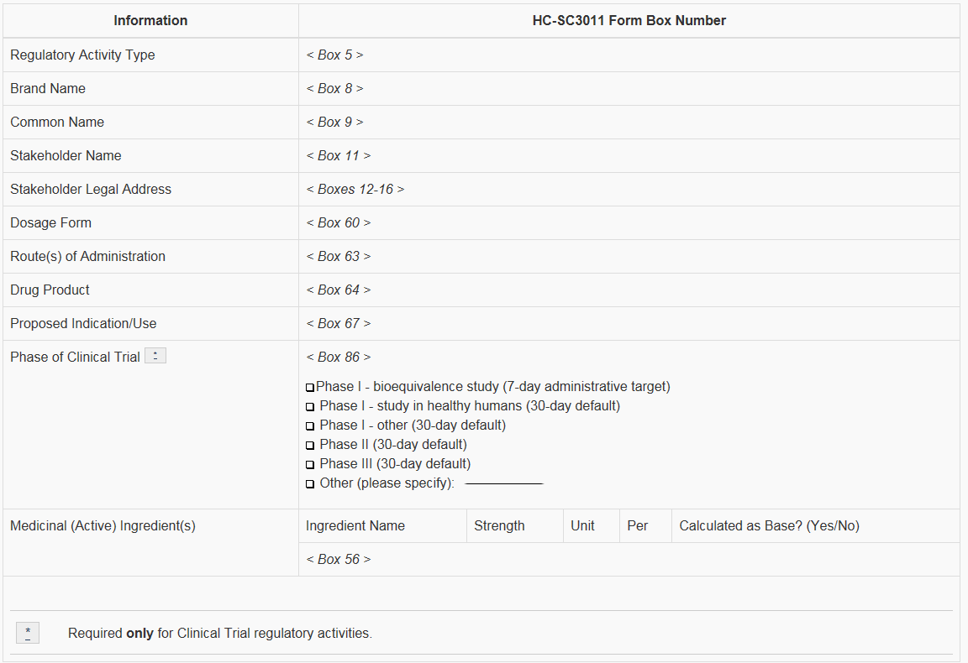

Next Steps:

- All documents must be saved electronically. Please refer to the Health Canada Guidance document, Appendix “D”, for the correct formatting/folder structure required for CTA submissions. http://hc-sc.gc.ca/CTA Preparation Electronic Format

- Forward electronic documents to linda.longpre@ucalgary.ca for review. Your documents will be reviewed for accuracy and completeness and will provide feedback to the study team if any corrections or changes are required. Once the application is deemed complete and accurate by the Quality Assurance Specialist, further instructions will be provided re: obtaining Institutional signatures.

Here is a link to the zip folder structure Health Canada prefers.

