
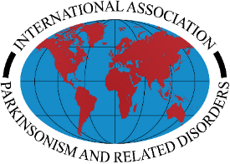

Melvin Yahr Parkinson’s Disease Clinical Research Award – Research Plan Instructions

The Research Plan should be a maximum of 6 pages. Please include the following sections in the proposal:
- Specific Aims – Describe the specific aims for the proposed project.
- Background/Research Rationale – Include a discussion of the significance and relevance for Parkinson's disease and clinical practice.
- Research Strategy – Provide preliminary data (if available), and details of proposed work, including experimental design (including statistical/data analysis plan), and a discussion of potential pitfalls and mitigation approaches.
- Overall Summary and Conclusion

References Cited – The literature cited should be limited to one (1) page. It will be uploaded as a separate attachment. It does not count towards the 6-page limit.

Formatting:
- Fonts: Must be 12 pt. Times New Roman or equivalent (≤15 cpi). Use symbol font (e.g., Greek letters) where necessary.
- Spacing: Maximum of 15 characters per inch and maximum 6 lines per inch (i.e., single spacing).
- Page: Page size must be 8.5” x 11” with a minimum of 0.5” margins on all sides.
- Figures: Included as part of text or at end. A descriptive legend with a minimum font size of 10 pt. Times New Roman or equivalent should be included.

